**Analysing Housing Prices In Metropolitan Areas Of India**

1. INTRODUCTION
   1. OVERVIEW

"Analyzing Housing Prices in Metropolitan Areas of India," focuses on examining the factors influencing property prices in major Indian cities. Through data analysis, you aim to identify key drivers like location, demand, and economic indicators to gain insights into the real estate market's dynamics in these urban centers, aiding potential buyers and investors. This research offers valuable information for understanding property trends in India's metropolitan areas, supporting informed decision-making in the housing market.

* 1. Purpose

The purpose of the project, "Analyzing Housing Prices in Metropolitan Areas of India," is to investigate and understand the factors that affect housing prices in major Indian cities. By conducting this analysis, you aim to provide valuable insights and information that can be used by various stakeholders, including potential homebuyers, real estate investors, government agencies, and urban planners. The project seeks to shed light on the dynamics of the real estate market in metropolitan areas of India, ultimately helping individuals and organizations make more informed decisions related to housing and real estate investments

1. PROBLEM DEFINITION AND DESIGN THINKING
   1. Empathy Map

2.2. Brainstorming Map

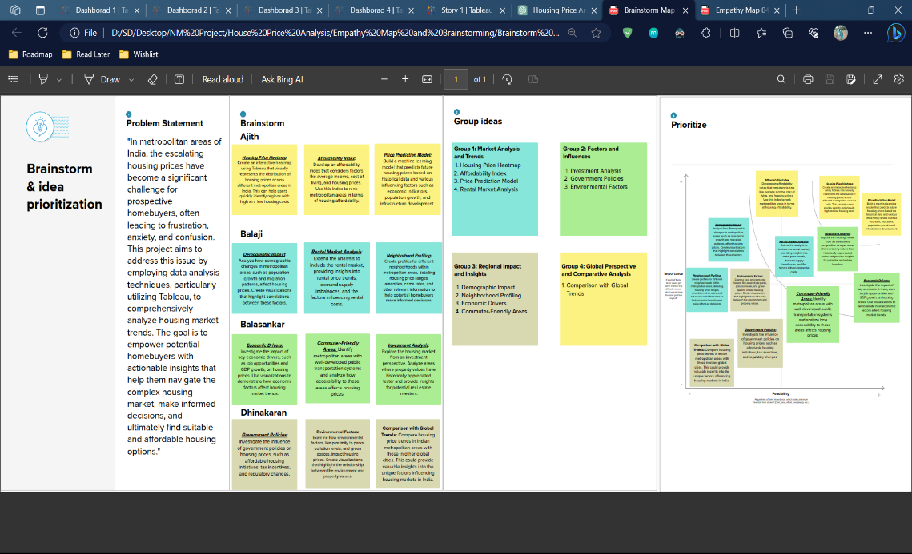

1. RESULT

Dashboard 1

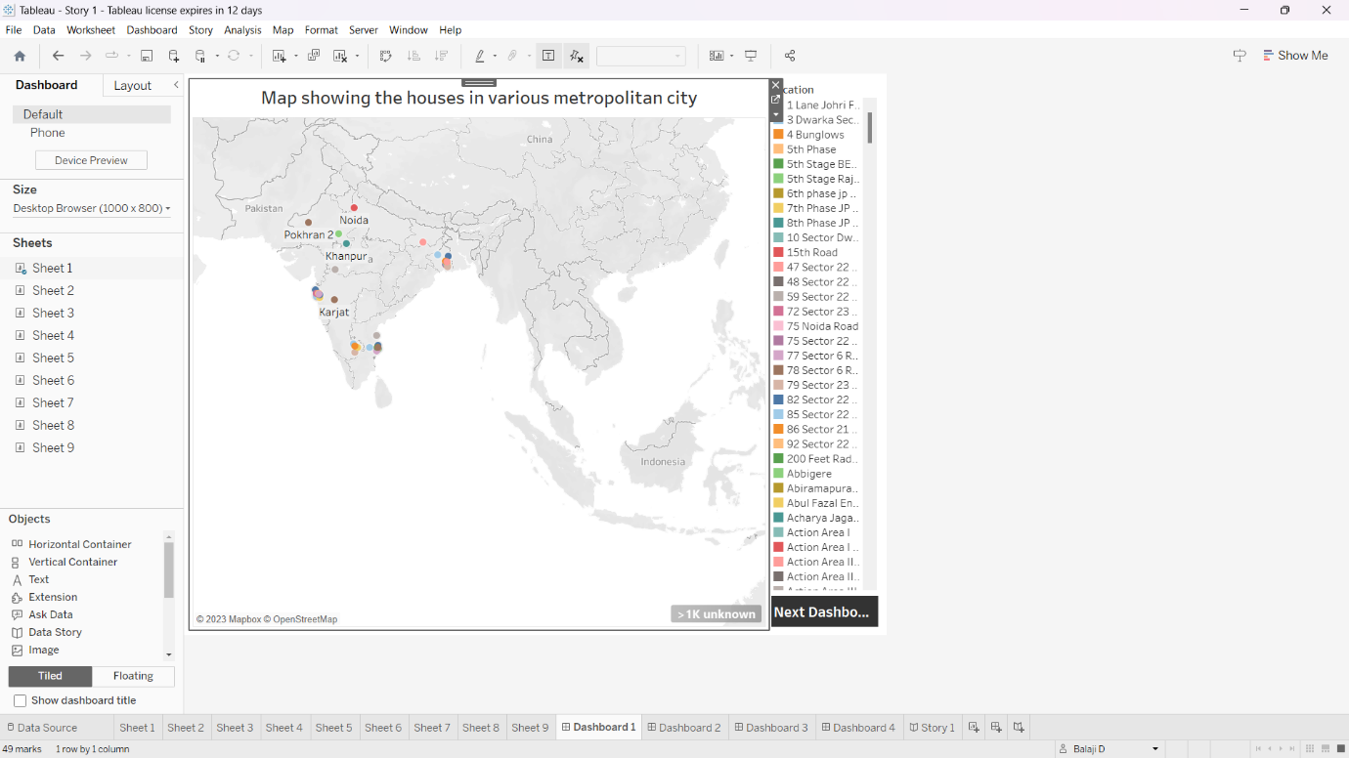

Dashboard 2

Dashboard 3

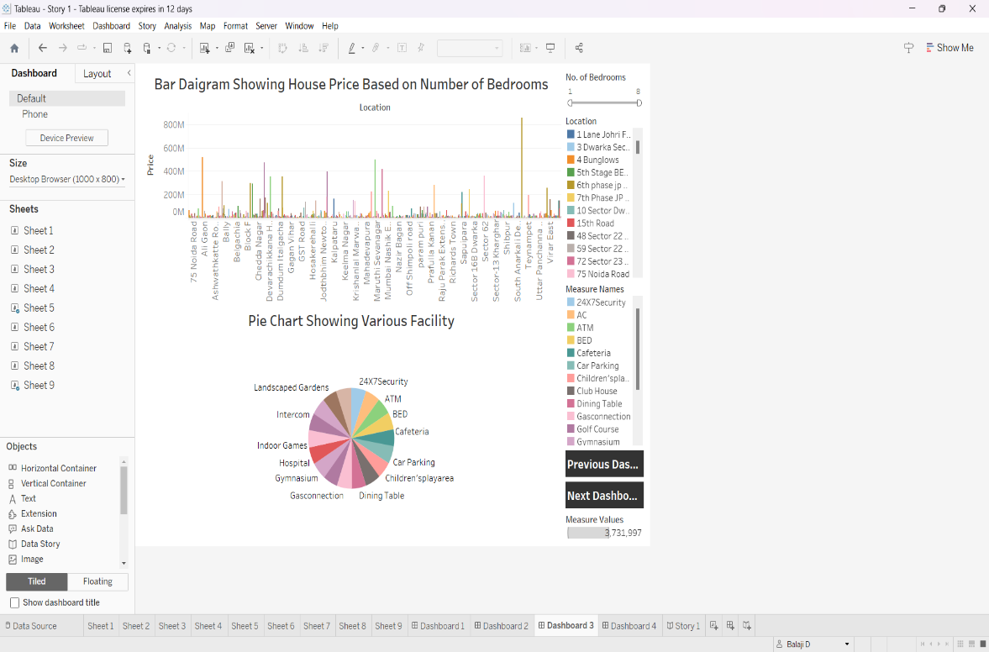

Dashboard 4

Story

1. ADVANTAGES AND DISADVANTAGES

ADVANTAGES

1. Informed Decision-Making: It provides valuable insights into the housing market, allowing potential buyers and investors to make informed decisions about where, when, and how to invest in real estate.
2. Market Transparency: Your project contributes to greater transparency in the real estate market, reducing information asymmetry and enhancing market efficiency.
3. Policy and Urban Planning: Findings from your research can assist government agencies and urban planners in making informed policy decisions related to housing and infrastructure development in metropolitan areas.
4. Economic Insights: Your project may uncover broader economic trends and indicators, providing a deeper understanding of the economic health and growth potential of different cities.

DISADVANTAGES

1. Data Limitations: Limited or unreliable data sources may hinder the accuracy of your analysis, leading to incomplete or skewed results.
2. Rapid Market Changes: The real estate market can be highly dynamic, and your analysis may quickly become outdated as market conditions evolve.
3. Overlooking Local Factors: Your project might not capture all the nuanced, local factors influencing housing prices, potentially oversimplifying a complex issue.
4. Ethical Considerations: Handling sensitive data related to housing and pricing might raise ethical concerns, particularly in terms of privacy and data protection
5. APPLICATIONS
6. **Real Estate Investment**: Investors can use your project's findings to identify areas with potential for high returns on real estate investments, helping them make informed decisions on where to purchase properties.
7. **Homebuyers**: Prospective homebuyers can use your research to understand the factors affecting property prices, enabling them to choose locations and properties that align with their budget and preferences.
8. **Urban Planning**: City planners and government agencies can use your analysis to inform urban development plans, infrastructure investments, and housing policies to address housing affordability and sustainable growth.
9. **Market Research**: Real estate developers and agents can leverage your project to assess market demand and pricing trends, allowing them to make more competitive and strategic decisions.
10. **Financial Institutions**: Banks and financial institutions may benefit from your research by gaining insights into the mortgage market, helping them tailor lending products and strategies.
11. **Academic Research**: Your project can serve as a valuable resource for researchers and academicians studying urban economics, real estate, and housing market dynamics in India.
12. **Housing NGOs**: Non-governmental organizations focused on housing and urban development can use your findings to advocate for policies and initiatives that address affordable housing needs in metropolitan areas.
13. **Homeowners' Associations**: Communities and homeowners' associations can utilize your analysis to better understand the property values in their neighborhoods, potentially influencing local decisions on zoning, maintenance, and community development.
14. **Property Valuation**: Appraisers and property valuation experts can incorporate your insights into their assessments of property values, ensuring more accurate and up-to-date valuations.
15. **International Investors**: International investors interested in the Indian real estate market can use your project to gain a better understanding of the dynamics and potential risks and opportunities in different metropolitan areas.Top of Form
16. CONCLUSION

In conclusion, the project "Analyzing Housing Prices in Metropolitan Areas of India" has provided valuable insights into the complex dynamics of the real estate market in India's major cities. By thoroughly examining various factors influencing housing prices, including location, demand, and economic indicators, this research has offered a deeper understanding of the housing market in metropolitan areas.

The project's findings are instrumental for a wide range of stakeholders, including investors, homebuyers, government agencies, and urban planners. It supports informed decision-making, fosters greater market transparency, and assists in shaping urban policies that address housing affordability and sustainable development.

However, it's crucial to recognize the limitations and potential challenges, such as data constraints and the ever-evolving nature of the real estate market. Future research and ongoing data collection will be necessary to keep the analysis current and relevant.

In summary, "Analyzing Housing Prices in Metropolitan Areas of India" serves as a valuable resource for individuals and organizations seeking to navigate the complex landscape of the Indian housing market. Its insights and recommendations contribute to better-informed decisions, potentially leading to more sustainable and equitable urban development in the years to come.

1. FUTURE SCOPE
2. **Longitudinal Analysis**: Continue tracking housing price trends over time to identify long-term patterns and changes. This will provide valuable insights into market stability and cyclical trends.
3. **Predictive Modeling**: Develop predictive models to forecast future housing prices based on historical data and key indicators. This can assist investors and homebuyers in making forward-looking decisions.
4. **Regional Expansion**: Expand your analysis to cover additional metropolitan areas in India to provide a more comprehensive understanding of the national real estate market.
5. **Advanced Data Sources**: Incorporate more advanced data sources, such as satellite imagery, geospatial data, and social media sentiment analysis, to gain deeper insights into factors affecting housing prices.
6. **Socioeconomic Analysis**: Consider adding a socio-economic component to your research to understand the impact of income, education, and employment on housing prices in metropolitan areas.
7. **Machine Learning and AI**: Utilize machine learning and artificial intelligence algorithms to extract more complex patterns and correlations from your data.
8. **Policy Implications**: Explore the policy implications of your research in greater detail, providing recommendations and insights for policymakers looking to address housing affordability and urban development.
9. **Collaboration**: Collaborate with real estate firms, urban planning departments, and housing advocacy groups to ensure the practical application of your research and to gather real-world data for validation.
10. **Global Comparisons**: Extend your research to include comparative analyses with housing markets in other countries or major cities around the world to identify similarities and differences.
11. **Data Visualization**: Enhance data visualization techniques to make your findings more accessible to a broader audience, including interactive maps and dashboards.
12. **Blockchain and Real Estate**: Investigate the potential of blockchain technology in real estate transactions and property record management, which could be a significant future development in the industry.
13. **Sustainability and Green Real Estate**: Assess the impact of sustainability practices on housing prices, as environmental considerations are becoming increasingly important in the real estate market.